1. **Site Overview**
   1. **Purpose of the Web site**

In Assignment 1, the purpose of Siberian Swirl Designs was to be the main shop for being able to purchase products for interested consumers, including bookmarks, home décor signs, and greeting cards. The secondary purpose was to act as a creative outlet blog for art enthusiasts and hobbyists parties. After evaluation from more in-depth research and discussion with usability partners, it was decided that the web site would become more of a blogging site and showcase for different designs with the optional link to purchase if so desired. The primary purpose was shifted due to research stating that just introducing hand lettered products to the World Wide Web is not the best method to develop association and desire for purchase. The goal of most art driven business is to develop a following, then to add the option of purchase. Megan Wells, another hand lettering artist, in her first published book, recently published, describes the need to drum up followers through social media and then to add an extension to an outside shop such as Etsy but to keep your main exhibits on your main site. Her own site only showcases her work and then links to two different shops for purchase, one focused on customized products and another for whatever is on her site, as is.

The purpose was also changed due to technical difficulties – a dynamic website is needed to display art as there are many pages involved as well as high quality images needed to load quickly. A website design team is usually more than one person, the business side and then the technical side and combining those responsibilities is not impossible but for a small business on the side, it is simply too much upkeep and developing. The change in purpose will allow for less coding, more creative purposes which in the end is more important in developing a small home-run business such as Siberian Swirl Designs. By adding the blog as one of the main components, it can bring in fellow artists and interested social media explorers, growing both the brand as well as a faithful following. After usability tests, it is indeed better for the website to focus more on the how-to blog and additional sketchbook blog (on Tumblr) than to just make it an e-commerce site.

* 1. **Information Goals**
     1. *Original Information Goals*
        1. Personal introduction
        2. Product Information
        3. Creative Outlet Blog
        4. Custom hand lettering product information
        5. Contact information
        6. Social media information/links
        7. Blog information
     2. *New Information Goals*
        1. Blog information
        2. Social Media Links
        3. Showcase of Work
        4. Product Information (link to Etsy)
        5. Contact information
     3. Why the changes to information goals?
        1. Research revealed different marketing techniques for hand lettering products (social media more important than previously thought)
        2. Initial design was too large and complicated for basic website.
           1. Limited storage space to consider
           2. No support if website should go down

1. **User Analysis, Information Architecture, and Results of Usability Tests**
   1. **Interviews & Interactions**
      1. *Interviews*
         1. Initial usability test with mock up was very informative as it was planned to remove the blog all together, but my partner, Kelly, convinced me otherwise. I thought the blog was going to be too complicated to do on the website, with much more information and less focus on my work but Kelly showed me some of her favorite crafting websites and showed me that the blog could be a good thing rather taking away from the first purpose of Siberian Swirl.
         2. I was being too critical when design Siberian Swirl Designs, thinking it was too complicated and confusing for the average Joe but after the first usability test, Kelly was an unbiased observer and her positive feedback helped. When designing a website, the designer worries about every path a user might take, trying to steer them in a certain direction – Kelly helped me pull away from that and focus on the website itself before worrying about all the avenues for users. It helped with the actual construction as I had feedback on what would be the most helpful for Siberian Swirl Designs.
      2. *Impact on Information Architecture*
         1. I changed the information architecture to be more user friendly with much less subpages and trying to keep the pages simple with all the information on the main pages with the option to go to subpages for product information.
         2. The first mock-up called for a very wide design and I figured out it needed to be contained so it would be compatible with mobiles and many different browsers than just Chrome. I used the basic template we used in class as it had components I thought would work best with the purpose of my site and is honestly much easier to code and work with once set up in Dreamweaver

|  |  |  |  |
| --- | --- | --- | --- |
| (Logo) Siberian Swirl Designs | Header Image | | |
| Home |
| About   * Mission * About Us * First Paw with Hand Lettering * Copyright Information * Site Map | **Welcome to Siberian Swirl Designs!**  We live in a digital age of brilliant designs that can be built entirely on a computer but sometimes people want to add that little something special to make it more meaningful. At Siberian Swirl Designs, we hand-letter greeting cards, home décor, bookmarks, and if you want to go the extra mile, custom items. Also, are you interested in hand lettering? Check out our blog for weekly designs, tips and techniques, and other fun stuff with hand lettering! | | |
| Shop   * Greeting Cards * Home Décor * Bookmarks * Custom Jobs | Bookmarks | Greeting Cards | Home Décor |
| Blog   * Muddy Paw Prints * Archive * Subscription | First Paw in with Hand Lettering  Curious about hand lettering art? Check this out as a brief introduction to hand lettering! | | |
| Social Media   * Facebook * Pinterest * Instagram * Tumblr | Latest Blog Post | | |
| Contact Information | Site Map | Copyright Information | | | Sibes Swirl Logo |

* 1. **Results from Usability Tests**
     1. My usability test, in retrospect, was way too complicated. Below were my usability questions:
        1. You’re a hobbyist and/or art enthusiast, where do you find pictures of Siberian Swirl Designs works, starting from the homepage?
        2. You’re a hobbyist looking for information about tools used for hand lettering, where do you go, starting from the homepage?
        3. You’re a hobbyist who would like to contact the administrator of Siberian Swirl Designs, where do you look to email the web master, starting at the home page?
        4. You’re a consumer, looking to purchase the “Too Many Candles” card, a single card, where do you go starting from the homepage?
        5. You’re a social media explorer and looking to share some of the images on Siberian Swirl Designs, how do you do this, starting from the home page?
     2. **USER 1 GINCUE:**



* + 1. **USER 2 GINCUE RESULTS:**



* + 1. **EES USER 1 Results**

|  |  |
| --- | --- |
| EES TABLE | |
| *Usability Factor* | *Average Rate* |
| Effectiveness | 9 |
| Efficiency | 6.5 |
| Satisfaction | 8 |
| **Overall** | **7.8333** |

* + 1. **EES User 2 Results**

|  |  |
| --- | --- |
| EES TABLE | |
| *Usability Factor* | *Average Rate* |
| Effectiveness | 9 |
| Efficiency | 6.5 |
| Satisfaction | 8 |
| **Overall** | **7.8333** |

* + 1. The number of options a user could take was too many for the test. While I wanted my website to have a web-shaped design with the ability to cross over different pages and wind up back where you originally were, if so desired, therefore made it more complicated and not very helpful in the end.
    2. A big complaint from my usability tests was that I had no search feature on my site so the easy avenue was not available and with the complex navigation, it frustrated some of my users.
    3. The fourth question pertaining to “Too Many Candles” was too confusing as I forgot to label the cards in the Shop main’s page and my images were too small for users to read the inside of the card without clicking on it to go to that page.
    4. Part of my usability test was simply to demonstrate to the users that it was an integrated design to have several paths to get the same answer but in looking back, it made things too confusing for an objective evaluation of the information architecture.
    5. For my test users, I chose a consumer and a social media follower for my tests, to ensure that I was getting the average Joe to the right page upon the first visit. While my results were good and evaluations were very high, I realized I needed objective users rather than semi-experts on the topic at hand. Each navigated the website in a different manner and while it was eye opening for some things (consumer was very annoyed that I didn’t have a search feature and social media follower pointed out there was not as many “share” features but rather following features). A combination of the two would have been more helpful than just the two.
  1. **Experience from personal Usability tests**
     1. As a designer, you try to incorporate as much as possible, like several ways to loop back to the homepage, quicker ways to load high quality images. Also, because you’ve done the same path – checking to make sure all the links work and reworking the code repeatedly, doing a run down by yourself is kind of pointless as it is almost second nature after completing the code.
     2. I am my own worst critic and doing my own usability tests made it hard because I kept constantly changing. I kept starting from scratch, remaking the whole site at least three times before landing on something that I liked.

1. **From Mock up to beta Web Site**
   1. **Changes in building from mockup to beta web site**
      1. The mock-up from Assignment 1 was scraped completely after the first usability tests. I sent my partner the whole assignment and she made it clear that if not, she would have been very confused. It was also much too wide for the average desktop computer, making the user scroll right and left which means less usability and easy frustration for the user.
      2. I redirected the focus from consumer priority to artist blog in the second shell, but not all the changes made it onto the beta website for the time limit and the coding limitations.
      3. I had a lot of problems finding the correct web hosting service as my website was much too large for the UNCG web space. I had to purchase my domain, set up an email, PayPal account for business, and more which took up a lot of my time meant for designing. The blog is also only a fledgling, much like the website, and I sincerely hope not too many people visit it right now as it works but not the standard I wish to display.
      4. 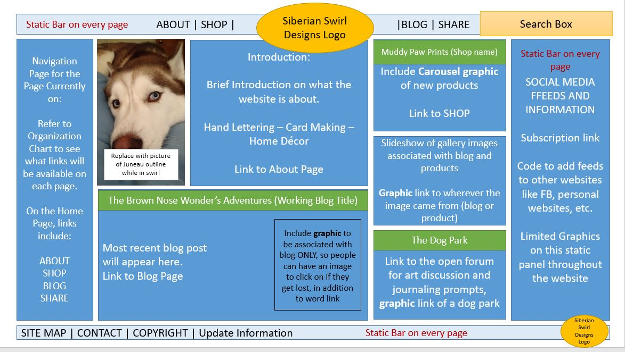There was a very big different between designing web pages and websites that I discovered throughout this project. The initial testing was on a single page (the home page) and I had wanted a site map to make sure users had that option for navigation but when I started adding up all the small pages (one webpage for each product) it was too much. I had to cull down to the basics which I feel took away from the dynamic website I designed.

Figure 1 Shell #1

* + 1. 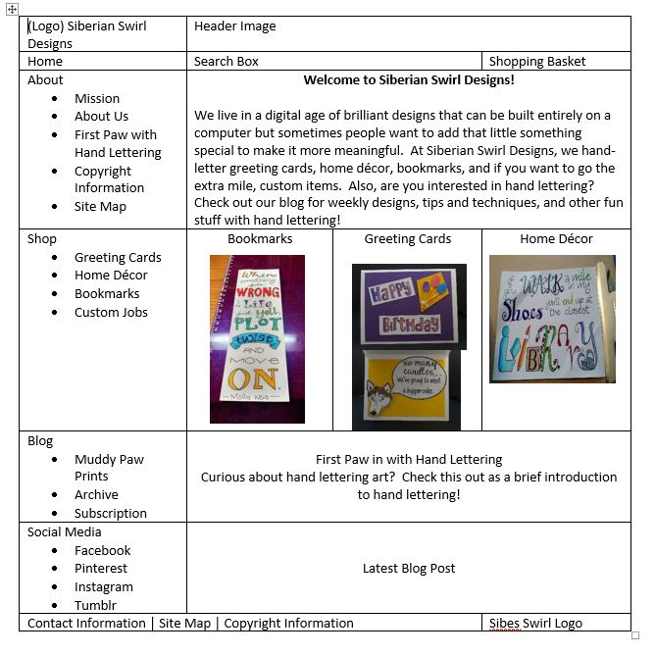Figure 1 is the first shell while Figure 2 is the second shell and then there is the website as it is now, which is still slightly different than either shell.

Figure 2 Shell #2

* 1. **Design decisions**
     1. In e-commerce, different colors entice different reactions in consumers. For example, yellow is meant to cause happiness or open feelings, good for inspiration products but it can overwhelm the consumer so best used in small amounts. I chose a cool, blue theme as it directly related back to the Siberian swirl reference (huskies in snow) while keeping the contrast ADA compliant with light blue or white backgrounds with dark navy text and then the menus were dark navy background with light blue (almost white) text. I did run into issues as the code for links made me change the color scheme so it was more light on dark where it was originally dark on light for the menus and important links – keeping it separate from the text which was always light background with dark text.
     2. I designed the logo using Adobe Illustrator and custom fonts and then using serif font, Palatino Linotype, for all text. The header and logo determined the color scheme for the web site.
     3. I had planned on having much more graphics but with limited space, I eliminated some of the more dynamic designs like the carousel of product images in the first mockup. The images were all JPEGs which is okay for websites, better than say TIF or GIF images, but they were taking a while to load onto the page. I’m not sure if it is the server size or the number of images but I made the website as static as possible, leaving the more complex images for the shop and blog websites, where the servers are designed to handle such a burden.

1. **Conclusion**
   1. **Is the web site highly usable?**
      1. The website needs some work before it can be dubbed a highly usable website. As it stands right now, it is usable but it is missing components to the site as a whole such as being able to share all images on the site and the search feature. It requires some more TLC before it can be shared on a wide scale such as through Facebook and adding to Google search engines.
   2. **Anticipated changes for Web 1.0**
      1. Adding a search feature below the header
      2. Making the shop available through Etsy, rather than designing a page for each product (web host not designed for that type of website)
      3. Making all images able to be “pinned” on Pinterest and share on Tumblr or Instagram
         1. Right now, the social media links are geared towards following Siberian Swirl Designs and/or me, rather than being able to share on a user’s own page